# 1st page code :-

<!DOCTYPE html>

<html lang="en">

<head>

<charset="UTF-8">

<name="viewport" content="width=device-width, initial-scale=1.0">

<title>Mizoram University Admission 2022</title>

<style> body { font-family: Arial, sans-serif; background-color: #f4f4f4;

}

.container { max-width: 1000px; margin: 20px auto; background-color: white; padding: 20px; border-radius: 8px; box-shadow: 0 2px 10px rgba(0, 0, 0, 0.1);

}

.header { background-color: #00a2c9;

color: white; padding: 15px; text-align: center; font-size: 1.5em; font-weight: bold;

}

.tab-header {

display: flex; margin: 10px 0; }

.tab-header div {

flex: 1;

text-align: center; padding: 10px; cursor: pointer;

}

.tab-header div.active { background-color: #f1f1f1; border-top: 2px solid #00a2c9;

}

form { margin-top: 20px;

}

form label { display: block; margin-bottom: 5px; font-weight: bold;

}

form input, form select { width: 100%; padding: 10px; margin-bottom: 20px; border: 1px solid #ccc; border-radius: 4px; box-sizing: border-box;

}

.form-section { margin-bottom: 25px;

}

.row {

display: flex;

justify-content: space-between; align-items: center; margin-bottom: 20px;

}

.row > div { flex: 1;

margin-right: 20px;

}

.row > div:last-child { margin-right: 0;

}

.row > div input, .row > div select { height: 45px;

}

.dob-fields { display: flex;

justify-content: space-between;

}

.dob-fields select { width: 32%;

}

.footer { text-align: center; margin-top: 30px; font-size: 0.8em; color: #888;

}

.container {

max-width: 1000px; margin: 20px auto; background-color: white; padding: 20px; border-radius: 8px; box-shadow: 0 2px 10px rgba(0, 0, 0, 0.1);

}

h2 { font-size: 1.4em; margin-bottom: 10px; border-bottom: 1px solid #ccc; padding-bottom: 10px;

}

.form-section { display: flex; flex-wrap: wrap; gap: 20px;

}

.name-fields {

display: flex; flex-wrap: wrap; gap: 20px;

}

.name-fields div {

flex: 1;

}

input { width: 100%; padding: 10px; border: 1px solid #ccc; border-radius: 4px; box-sizing: border-box;

}

.container { max-width: 1000px; margin: 20px auto; background-color: white; padding: 20px; border-radius: 8px; box-shadow: 0 2px 10px rgba(0, 0, 0, 0.1);

}

h2 { font-size: 1.4em; margin-bottom: 10px; border-bottom: 1px solid #ccc; padding-bottom: 10px;

}

.form-section {

display: flex; flex-wrap: wrap; gap: 20px;

}

.name-fields { display: flex; flex-wrap: wrap; gap: 20px;

}

.name-fields div {

flex: 1;

}

input, select { width: 100%; padding: 10px; border: 1px solid #ccc; border-radius: 4px; box-sizing: border-box;

}

.container { max-width: 1000px; margin: 20px auto; background-color: white; padding: 20px; border-radius: 8px; box-shadow: 0 2px 10px rgba(0, 0, 0, 0.1);

}

h2 { font-size: 1.4em; margin-bottom: 10px; border-bottom: 1px solid #ccc; padding-bottom: 10px;

}

.form-section { display: flex; flex-wrap: wrap; gap: 20px;

}

.name-fields {

display: flex; flex-wrap: wrap; gap: 20px;

}

.name-fields div {

flex: 1;

}

input, select { width: 100%; padding: 10px; border: 1px solid #ccc; border-radius: 4px; box-sizing: border-box;

}

.container { max-width: 1000px; margin: 20px auto; background-color: white; padding: 20px; border-radius: 8px; box-shadow: 0 2px 10px rgba(0, 0, 0, 0.1);

}

h2 { font-size: 1.4em; margin-bottom: 10px; border-bottom: 1px solid #ccc; padding-bottom: 10px;

}

h3 { font-size: 1.2em; margin-bottom: 10px; border-bottom: 1px solid #eee; padding-bottom: 5px;

}

.form-section {

display: flex; gap: 40px;

}

.address-column {

flex: 1; }

input, select { width: 100%; padding: 10px; margin-bottom: 10px; border: 1px solid #ccc; border-radius: 4px; box-sizing: border-box;

}

input[type="checkbox"] { margin-right: 10px;

}

.bank-details { display: grid;

grid-template-columns: repeat(2, 1fr); gap: 20px;

}

.bank-details label { grid-column: span 1;

}

.bank-details input { grid-column: span 1;

}

.error-message {

color: red; font-size: 0.85em;

}

.button-section {

text-align: center; margin-top: 20px;

}

.save-next-button { background-color: white; border: 1px solid #ccc; border-radius: 5px; padding: 10px 20px; font-size: 16px; color: blue; cursor: pointer;

}

.save-next-button:hover { background-color: #f0f0f0;

}

</style>

</head>

<body>

<div class="container">

<div class="header">

Mizoram University Admission 2022

</div>

<div class="tab-header">

<div class="active">Profile Detail</div>

<div>Other Detail</div>

<div>Upload</div>

</div>

<form>

<div class="form-section">

<div class="row">

<div>

<label for="firstName">First Name *</label>

<input type="text" id="firstName" name="firstName" required>

</div>

<div>

<label for="middleName">Middle Name</label>

<input type="text" id="middleName" name="middleName">

</div>

<div>

<label for="lastName">Last Name *</label>

<input type="text" id="lastName" name="lastName" required>

</div>

</div>

<div class="row">

<div>

<label for="gender">Applicant's Gender *</label>

<select id="gender" name="gender" required>

<option value="" disabled selected>Select</option>

<option value="male">Male</option>

<option value="female">Female</option>

<option value="other">Other</option>

</select>

</div>

</div>

<div class="row">

<div>

<label for="dob">Applicant's Date of Birth *</label>

<div class="dob-fields">

<select id="dob-day" name="dob-day" required>

<option value="" disabled selected>Day</option>

</select>

<select id="dob-month" name="dob-month" required>

<option value="" disabled selected>Month</option>

</select>

<select id="dob-year" name="dob-year" required>

<option value="" disabled selected>Year</option>

</select>

</div>

</div>

<div>

<label for="age">Age as on Jul 1, 2021 *</label>

<input type="number" id="age" name="age" readonly>

</div>

<div>

<label for="category">Category *</label>

<select id="category" name="category" required>

<option value="" disabled selected>Select</option>

<option value="general">General</option>

<option value="sc">SC</option>

<option value="st">ST</option>

<option value="obc">OBC</option>

</select>

</div>

</div>

<div class="row">

<div>

<label for="email">Applicant's Email *</label>

<input type="email" id="email" name="email" required>

</div>

<div>

<label for="altEmail">Alternate Email</label>

<input type="email" id="altEmail" name="altEmail">

</div>

<div>

<label for="mobile">Mobile Number *</label>

<input type="tel" id="mobile" name="mobile" required>

</div>

<div>

<label for="altMobile">Alternate Mobile Number</label>

<input type="tel" id="altMobile" name="altMobile">

</div>

</div>

<div class="row">

<div>

<label for="aadhar">Applicant's Aadhar Card Number</label>

<input type="text" id="aadhar" name="aadhar">

</div>

<div>

<label for="bloodGroup">Blood Group</label>

<select id="bloodGroup" name="bloodGroup">

<option value="" disabled selected>Select</option>

<option value="A+">A+</option>

<option value="A-">A-</option>

<option value="B+">B+</option>

<option value="B-">B-</option>

<option value="O+">O+</option>

<option value="O-">O-</option>

<option value="AB+">AB+</option>

<option value="AB-">AB-</option>

</select>

</div>

<div>

<label for="citizen">Are you a citizen of India? *</label>

<select id="citizen" name="citizen" required>

<option value="" disabled selected>Select</option>

<option value="yes">Yes</option>

<option value="no">No</option>

</select>

</div>

<div>

<label for="religion">Religion *</label>

<select id="religion" name="religion" required>

<option value="" disabled selected>Select</option>

<option value="hindu">Hindu</option>

<option value="muslim">Muslim</option>

<option value="christian">Christian</option>

<option value="other">Other</option>

</select>

</div>

</div>

</div>

<div class="container">

<h2>Place of Birth Details</h2>

<div class="form-section">

<div class="name-fields">

<div>

<label for="village">Village/Town/City *</label>

<input type="text" id="village" name="village" required>

</div>

<div>

<label for="country">Country *</label>

<input type="text" id="country" name="country" required>

</div>

<div>

<label for="state">State *</label>

<input type="text" id="state" name="state" required>

</div>

<div>

<label for="district">District *</label>

<input type="text" id="district" name="district" required>

</div>

</div>

</div>

<h2>Family Details</h2>

<div class="form-section">

<div class="name-fields">

<div>

<label for="motherName">Mother's Name *</label>

<input type="text" id="motherName" name="motherName" required>

</div>

<div>

<label for="fatherName">Father's/Guardian's Name *</label>

<input type="text" id="fatherName" name="fatherName" required>

</div>

</div>

</div>

</div>

<div class="container">

<h2>Mizoram University registration details (if applicable)</h2>

<div class="form-section">

<div class="name-fields">

<div>

<label for="registered">Are you already registered in Mizoram University? *</label>

<select id="registered" name="registered" required>

<option value="">Select</option>

<option value="yes">Yes</option>

<option value="no">No</option>

</select>

</div>

<div>

<label for="regNumber">Please enter registration number</label>

<input type="text" id="regNumber" name="regNumber">

</div>

<div>

<label for="college">Name of Mizoram University Department/Affiliated College *</label> <input type="text" id="college" name="college" required>

</div>

<div>

<label for="program">Programme registered in</label>

<input type="text" id="program" name="program">

</div>

<div>

<label for="year">Year of Registration</label>

<select id="year" name="year">

<option value="">Select</option>

<option value="2020">2020</option>

<option value="2021">2021</option> <option value="2022">2022</option>

</select>

</div>

</div>

</div>

</div>

<div class="container">

<h2>Other Category/Quota</h2>

<div class="form-section">

<div class="name-fields">

<div>

<label for="pwdCategory">Persons with Disabilities (PwD) Category *</label>

<select id="pwdCategory" name="pwdCategory" required>

<option value="">Select</option>

<option value="Yes">Yes</option>

<option value="No">No</option>

</select>

</div>

<div>

<label for="armedForcesCategory">Children/Widows of Armed Forces Personnel *</label>

<select id="armedForcesCategory" name="armedForcesCategory" required>

<option value="">Select</option>

<option value="Yes">Yes</option>

<option value="No">No</option>

</select>

</div>

</div>

</div>

</div>

<div class="container">

<h2>Address</h2>

<div class="form-section">

<div class="address-column">

<h3>Correspondence Address</h3>

<label for="correspondenceAddress">Address *</label>

<input type="text" id="correspondenceAddress" name="correspondenceAddress" required>

<label for="correspondenceDistrict">District *</label>

<input type="text" id="correspondenceDistrict" name="correspondenceDistrict" required>

<label for="correspondenceCountry">Country *</label>

<select id="correspondenceCountry" name="correspondenceCountry" required>

<option value="">Select</option>

<option value="India">India</option>

<option value="Other">Other</option>

</select>

<label for="correspondenceState">State *</label>

<select id="correspondenceState" name="correspondenceState" required>

<option value="">Select</option>

<!-- Add state options here -->

</select>

<label for="correspondenceCity">City *</label>

<input type="text" id="correspondenceCity" name="correspondenceCity" required>

<label for="correspondencePincode">Pincode *</label>

<input type="text" id="correspondencePincode" name="correspondencePincode" required> </div>

<div class="address-column">

<h3>Permanent Address</h3>

<label for="sameAsCorrespondence">

<input type="checkbox" id="sameAsCorrespondence" name="sameAsCorrespondence"> Click if Same As Correspondence Address

</label>

<label for="permanentAddress">Address *</label>

<input type="text" id="permanentAddress" name="permanentAddress" required>

<label for="permanentDistrict">District *</label>

<input type="text" id="permanentDistrict" name="permanentDistrict" required>

<label for="permanentCountry">Country *</label>

<select id="permanentCountry" name="permanentCountry" required>

<option value="">Select</option>

<option value="India">India</option>

<option value="Other">Other</option>

</select>

<label for="permanentState">State *</label>

<select id="permanentState" name="permanentState" required>

<option value="">Select</option>

</select>

<label for="permanentCity">City *</label>

<input type="text" id="permanentCity" name="permanentCity" required>

<label for="permanentPincode">Pincode *</label>

<input type="text" id="permanentPincode" name="permanentPincode" required>

</div>

</div>

<h2>Bank Details for Financial Assistance and Refund (if applicable)</h2>

<p>If you don’t have your own bank account, please provide details of your parent/guardian’s bank account where you would like to receive the refund (if any).</p>

<div class="bank-details">

<label for="accountHolderName">Name of the Account Holder *</label>

<input type="text" id="accountHolderName" name="accountHolderName" required>

<small class="error-message">Name of the Account Holder cannot be blank</small>

<label for="accountNumber">Account Number *</label>

<input type="text" id="accountNumber" name="accountNumber" required>

<small class="error-message">Account Number cannot be blank</small>

<label for="confirmAccountNumber">Confirm Account Number *</label>

<input type="text" id="confirmAccountNumber" name="confirmAccountNumber" required>

<label for="bankName">Name of the Bank *</label>

<input type="text" id="bankName" name="bankName" required>

<label for="ifscCode">IFSC Code *</label>

<input type="text" id="ifscCode" name="ifscCode" required>

</div>

</div>

<div class="button-section">

<button type="submit" class="save-next-button">Save and Next</button>

</div>

</form>

<div class="footer">

© Mizoram University 2022 | Powered by PROJECT SAMARTH

</div>

</div>

</body>

</html>

# 1st page output :-

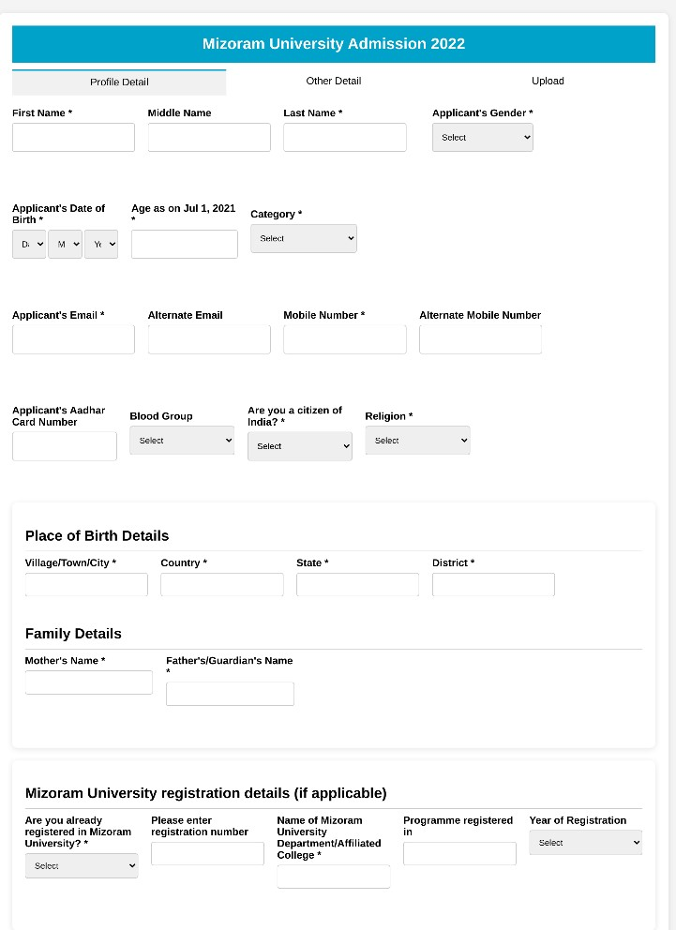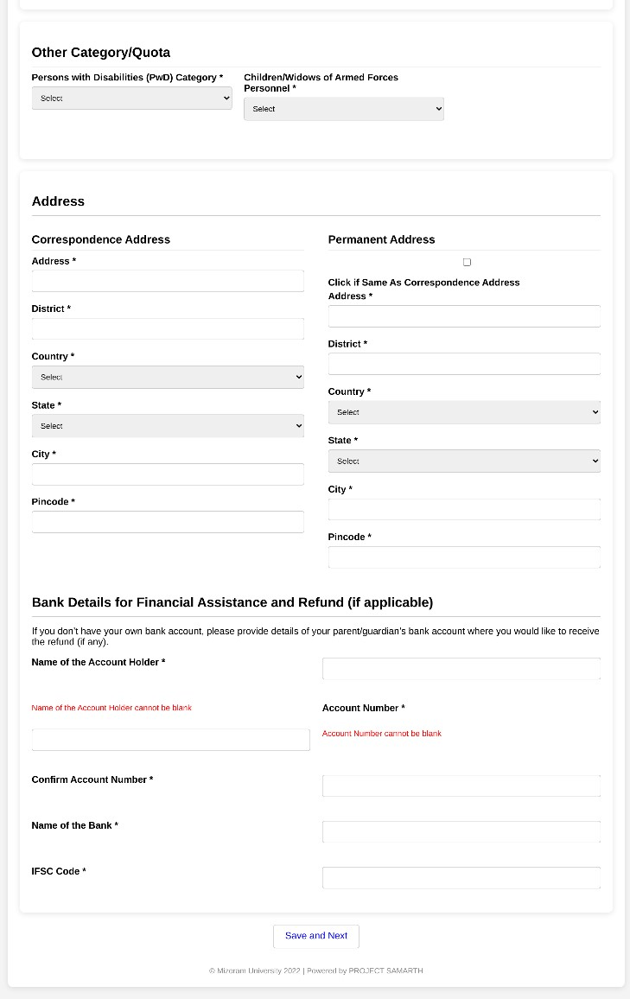

# 2nd page code :-

<!DOCTYPE html>

<html lang="en">

<head>

<charset="UTF-8">

<name="viewport" content="width=device-width, initial-scale=1.0">

<title>Mizoram University Admission 2022</title>

<style> body { font-family: Arial, sans-serif; background-color: #f7f7f7; margin: 0; padding: 0;

}

.container { width: 60%; margin: 50px auto; background-color: #fff; border-radius: 8px; box-shadow: 0 0 10px rgba(0, 0, 0, 0.1);

}

.header {

background-color: #008080; padding: 20px; color: white; text-align: left;

border-top-left-radius: 8px; border-top-right-radius: 8px;

}

.header img { float: left; margin-right: 20px;

}

.header h1 { margin: 0; font-size: 1.5em;

}

.tabs { display: flex;

justify-content: space-between; background-color: #e5e5e5; padding: 10px;

}

.tabs div { flex: 1; text-align: center; padding: 10px; font-weight: bold; cursor: pointer;

}

.tabs div.active {

background-color: #008080; color: white;

}

.form-container { padding: 20px;

}

.form-group { margin-bottom: 20px;

display: flex;

justify-content: space-between; align-items: center;

}

label { width: 30%; font-weight: bold;

}

select, input[type="text"] { width: 65%; padding: 10px; border: 1px solid #ccc; border-radius: 5px;

}

.language-table { width: 100%; border-collapse: collapse; margin-top: 20px;

}

.language-table th, .language-table td { padding: 10px; border: 1px solid #ddd; text-align: center;

}

.language-table th { background-color: #f0f0f0; font-weight: bold;

}

.language-table td input[type="checkbox"] {

margin-right: 5px;

}

.buttons {

margin-top: 30px; display: flex; justify-content: space-between;

}

.btn {

padding: 10px 20px; font-size: 16px; color: white; border: none; border-radius: 5px; cursor: pointer;

}

.btn-profile { background-color: #6c757d;

}

.btn-save-next { background-color: #28a745;

}

.btn:hover { opacity: 0.8;

}

</style>

</head>

<body>

<div class="container">

<div class="header">

<h1>Mizoram University Admission 2022</h1>

</div>

<div class="tabs">

<div>Profile Details</div>

<div class="active">Other Details</div>

<div>Upload</div>

</div>

<div class="form-container">

<form action="#" method="post">

<!-- Illness -->

<div class="form-group">

<label for="illness">Do you have any illness which requires continuous or emergency medical attention?</label>

<select id="illness" name="illness">

<option value="">Select</option>

<option value="yes">Yes</option>

<option value="no">No</option>

</select>

</div>

<div class="form-group">

<label for="nss">Have you participated in National Service Scheme (NSS)?</label>

<select id="nss" name="nss">

<option value="">Select</option>

<option value="yes">Yes</option>

<option value="no">No</option>

</select>

</div>

<div class="form-group">

<label for="sports">Are you a sports person?</label>

<select id="sports" name="sports">

<option value="">Select</option>

<option value="yes">Yes</option>

<option value="no">No</option>

</select>

</div>

<table class="language-table">

<thead>

<tr>

<th>Language</th>

<th>Reading</th>

<th>Writing</th>

<th>Speaking</th>

</tr>

</thead>

<tbody>

<tr>

<td>English</td>

<td><input type="checkbox" name="english_read"></td>

<td><input type="checkbox" name="english_write"></td>

<td><input type="checkbox" name="english_speak"></td>

</tr>

<tr>

<td>Hindi</td>

<td><input type="checkbox" name="hindi_read"></td>

<td><input type="checkbox" name="hindi_write"></td>

<td><input type="checkbox" name="hindi_speak"></td>

</tr>

<tr>

<td><input type="text" name="other_language1" placeholder="Other Language 1"></td>

<td><input type="checkbox" name="other1_read"></td>

<td><input type="checkbox" name="other1_write"></td>

<td><input type="checkbox" name="other1_speak"></td>

</tr>

<tr>

<td><input type="text" name="other_language2" placeholder="Other Language 2"></td>

<td><input type="checkbox" name="other2_read"></td>

<td><input type="checkbox" name="other2_write"></td>

<td><input type="checkbox" name="other2_speak"></td>

</tr>

</tbody>

</table>

<div class="buttons">

<button type="button" class="btn btn-profile">Profile</button>

<button type="submit" class="btn btn-save-next">Save & Next</button>

</div>

</form>

</div>

</div>

</body>

</html>

# 2nd page output :-

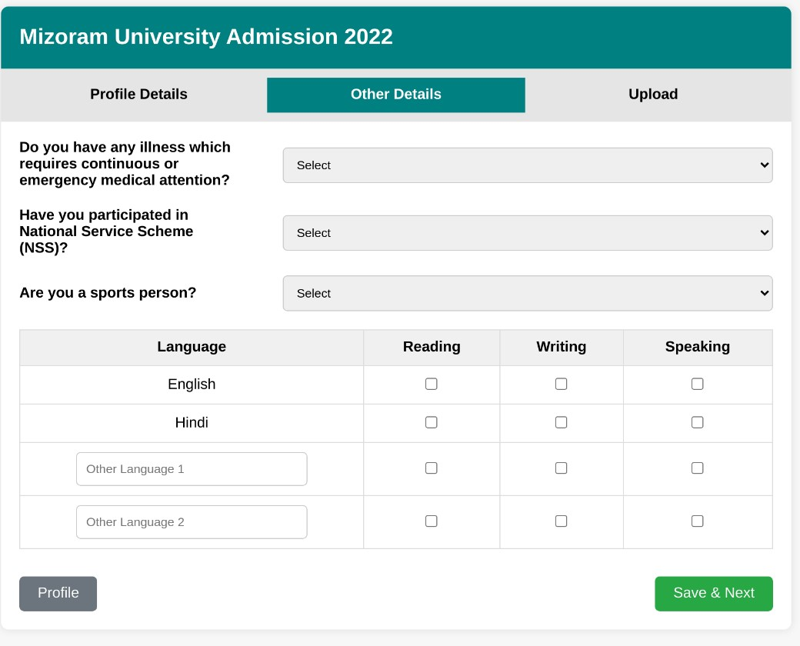

# 3rd page code :-

<!DOCTYPE html>

<html lang="en">

<head>

<meta charset="UTF-8">

<meta name="viewport" content="width=device-width, initial-scale=1.0">

<title>Profile Upload</title>

<style> body { font-family: Arial, sans-serif;

}

.container { margin: 20px;

}

.heading { color: red; font-weight: bold;

} table {

width: 100%; border-collapse: collapse;

} td { padding: 10px;

} .btn {

background-color: green;

color: white; padding: 10px; border: none; cursor: pointer; text-align: center;

}

.btn:hover { background-color: darkgreen;

}

.previous { background-color: skyblue; padding: 10px; cursor: pointer;

}

.submit { background-color: red;

color: white; padding: 10px; cursor: pointer;

}

</style>

</head>

<body>

<div class="container">

<h2 class="heading">Instruction for Uploading Image/Photo of Document, Certificate, Marksheet and Signature</h2>

<ul>

<li>Digital Photo and Signature are required in .jpg or .jpeg image format.</li>

<li>File size of digital photo must be within 10kb to 1024kb limit.</li>

<li>Document/Certificate/Marksheet related size of digital photo must be within 10kb to 1024kb limit.</li>

<li>For Qualification Status marked as "Appearing" (Graduation), Merged

Document/Certificate/Marksheet of I, II, III, IV, V Semesters in PDF Format with size 2Mb limit is to be uploaded.</li>

<li>For Qualification Status marked as "Appearing" (Master), Merged

Document/Certificate/Marksheet of I, II, III Semesters in PDF Format with size 2Mb limit is to be uploaded.</li>

</ul>

<table border="1">

<tr>

<td>Photo</td>

<td>Accepted formats: .jpeg, .jpg</td>

<td><button class="btn">Select file</button></td>

</tr>

<tr>

<td>Signature</td>

<td>Accepted formats: .jpeg, .jpg</td>

<td><button class="btn">Select file</button></td>

</tr>

</table>

<div style="margin-top: 20px;">

<button class="previous">Previous</button>

<button class="submit">Submit Profile</button>

</div>

</div>

</body>

</html>

# 3rd page output :-

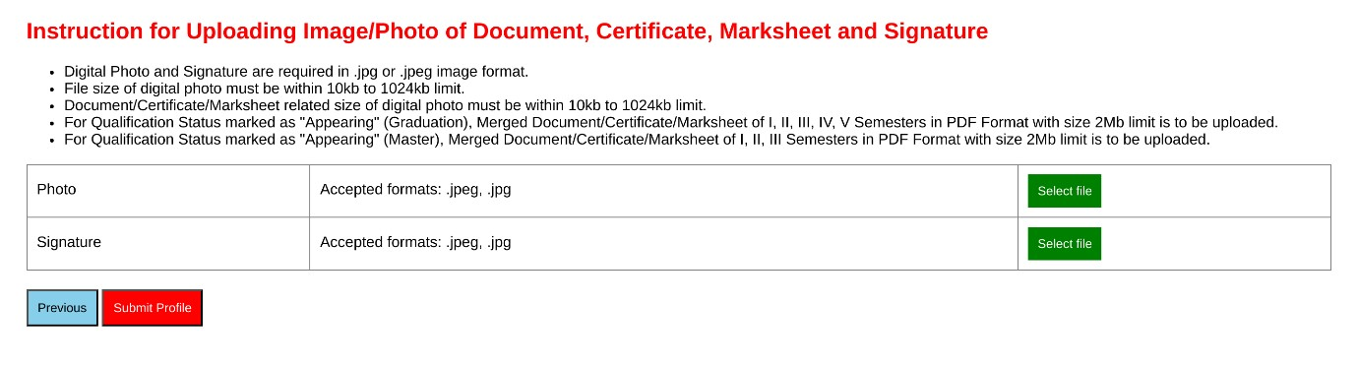

# 4thpage code :-

<!DOCTYPE html>

<html lang="en">

<head>

<meta charset="UTF-8">

<meta name="viewport" content="width=device-width, initial-scale=1.0">

<title>Mizoram University Admission 2022</title>

<style> body { font-family: Arial, sans-serif; background-color: #f0f8f8;

}

.header {

background-color: #0097a7;

color: white; padding: 15px;

text-align: left; display: flex;

justify-content: space-between; align-items: center;

}

.header img { height: 50px;

}

.header a { color: white; margin-left: 20px; text-decoration: none;

}

.container { margin: 20px; padding: 20px; background-color: white; border-radius: 8px; box-shadow: 0 4px 8px rgba(0, 0, 0, 0.1);

}

.container h1 { color: green; font-size: 20px;

}

.basic-details, .profile-details, .program-selection { margin-top: 20px; padding: 10px; border: 1px solid #ccc; border-radius: 5px;

}

.basic-details .detail-item, .profile-details .detail-item { margin-bottom: 10px;

}

.detail-item span { display: inline-block; width: 150px; font-weight: bold;

}

.helpdesk-btn { color: red; border: 1px solid red; background-color: white; padding: 5px 10px; border-radius: 4px; text-decoration: none;

}

.helpdesk-btn:hover { background-color: red;

color: white;

}

.apply-btn { background-color: #0097a7;

color: white; padding: 10px 20px; border: none; border-radius: 5px; cursor: pointer; font-size: 16px;

}

.apply-btn:hover { background-color: #007d8a;

}

</style>

</head>

<body>

<div class="header">

<div>

<img src="https://upload.wikimedia.org/wikipedia/en/5/57/Mizoram_University_Logo.png" alt="Mizoram University Logo">

<span>Mizoram University Admission 2022</span>

</div>

<div>

<a href="#">Download Admission Notice</a>

<a href="#">Download Prospectus</a>

<a href="#">Visit Mizoram University Website</a>

</div>

<div>

<img src="https://via.placeholder.com/50" alt="Profile Image">

<span>Name</span>

</div>

</div>

<div class="container">

<h1>Profile Submitted successfully. You can now apply for programmes.</h1>

<div class="basic-details">

<h3>Basic Details</h3>

<div class="detail-item">

<span>Email ID:</span>

</div>

<div class="detail-item">

<span>Mobile Number:</span>

</div>

<a href="#" class="helpdesk-btn">Contact Helpdesk</a>

</div>

<div class="profile-details">

<h3>Profile Detail</h3>

<p>It includes all the personal details including the category, place of birth details, family details, address details, etc.</p>

<button class="apply-btn">View</button>

</div>

<div class="program-selection">

<h3>Programme Selection</h3>

<p>Choose the program you want to apply for</p>

<button class="apply-btn">Apply Now</button>

</div>

</div>

</body>

</html>

# 4th page output :-

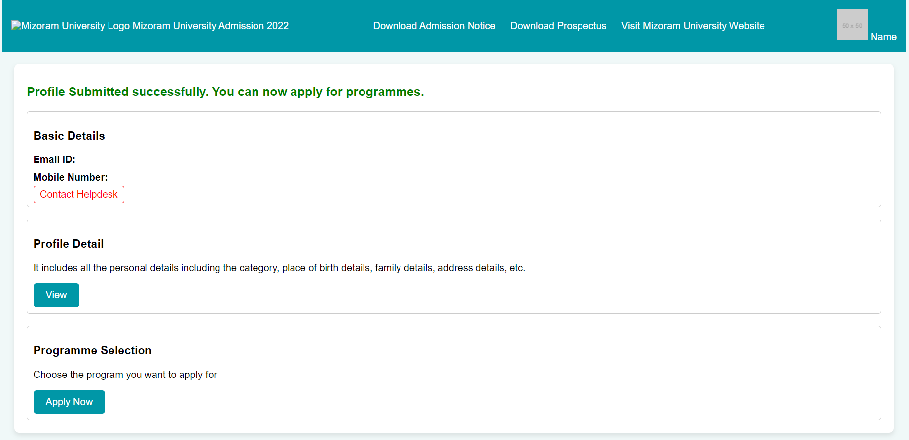

# 5th page code :-

<!DOCTYPE html>

<html lang="en">

<head>

<meta charset="UTF-8">

<meta name="viewport" content="width=device-width, initial-scale=1.0">

<title>Programme Selection</title>

<style> body { font-family: Arial, sans-serif; background-color: #f4f4f4; padding: 20px;

}

.tabs { display: flex; margin-bottom: 20px; background-color: #ddd; border-radius: 8px; overflow: hidden;

}

.tab-item {

flex: 1; padding: 10px; text-align: center; background-color: #eee; border-right: 1px solid #ccc; cursor: pointer; position: relative;

}

.tab-item:last-child {

border-right: none;

}

.tab-item.active { background-color: white; border-bottom: 3px solid #007bff; font-weight: bold;

}

.tab-item .number {

display: block; background-color: #007bff;

color: white; border-radius: 50%; width: 20px; height: 20px; text-align: center; line-height: 20px; font-size: 12px; position: absolute; top: -5px; right: 10px;

}

.container { background-color: white; padding: 20px; border-radius: 8px; box-shadow: 0 2px 4px rgba(0, 0, 0, 0.1);

}

.container h3 { margin-bottom: 20px;

}

.container select, .container input {

width: 100%; padding: 10px; margin-bottom: 20px; border-radius: 5px; border: 1px solid #ccc;

}

.button-container {

display: flex;

justify-content: space-between; margin-top: 20px;

}

.button-container button { width: 48%; padding: 15px; border: none; border-radius: 5px; color: white; font-size: 16px; cursor: pointer;

}

.button-container .home-btn { background-color: #17a2b8;

}

.button-container .next-btn { background-color: #007bff;

}

</style>

</head>

<body>

<div class="tabs">

<div class="tab-item active">

Programme Selection

<span class="number">1</span>

</div>

<div class="tab-item">

Personal Details

<span class="number">2</span>

</div>

<div class="tab-item">

Academic Details

<span class="number">3</span>

</div>

<div class="tab-item">

NET/Equiv Details

<span class="number">4</span>

</div>

<div class="tab-item">

Other Details

<span class="number">5</span>

</div>

<div class="tab-item">

Uploads

<span class="number">6</span>

</div>

<div class="tab-item">

Preview

<span class="number">7</span>

</div>

<div class="tab-item">

Payments

<span class="number">8</span> </div>

</div>

<div class="container">

<h3>Select the Programme you want to apply</h3>

<label for="programme-level">Programme Level</label>

<select id="programme-level" name="programme-level">

<option value="" disabled selected>Select</option>

<option value="undergraduate">Undergraduate</option>

<option value="postgraduate">Postgraduate</option>

<option value="doctorate">Doctorate</option>

</select>

<label for="programme">Programme <span style="color: red;">*</span></label>

<select id="programme" name="programme">

<option value="" disabled selected>Select</option>

<option value="bachelor-of-science">Bachelor of Science</option>

<option value="bachelor-of-arts">Bachelor of Arts</option>

<option value="master-of-science">Master of Science</option>

<option value="phd">PhD</option>

</select>

<!-- Diploma Details Section -->

<h3>Academic Details</h3>

<label for="diploma-name">Name of the Diploma</label>

<input type="text" id="diploma-name" name="diploma-name" placeholder="Enter Diploma Name">

<label for="diploma-percentage">Percentage Obtained in the Diploma</label>

<input type="text" id="diploma-percentage" name="diploma-percentage" placeholder="Enter Percentage">

<label for="diploma-year">Passing Year of the Diploma</label>

<select id="diploma-year" name="diploma-year">

<option value="" disabled selected>Select</option>

<option value="2024">2024</option>

<option value="2023">2023</option>

<option value="2022">2022</option>

<option value="2021">2021</option>

<option value="2020">2020</option>

<!-- Add more years as needed -->

</select>

<div class="container">

<h3>National Level Admission Test Details</h3>

<label for="admission-test">National Level Admission Test</label>

<select id="admission-test" name="admission-test" style="width: 100%; padding: 10px; marginbottom: 20px; border-radius: 5px; border: 1px solid #ccc;">

<option value="" disabled selected>Select</option>

<option value="exam1">Exam 1</option>

<option value="exam2">Exam 2</option>

<option value="exam3">Exam 3</option>

<!-- Add more options as needed -->

</select>

<label for="test-score">Score Obtained on National Level Admission Test</label>

<input type="text" id="test-score" name="test-score" placeholder="Enter your score" style="width: 100%; padding: 10px; margin-bottom: 20px; border-radius: 5px; border: 1px solid #ccc;">

<label for="eligibility-criteria">Select Eligibility Criteria</label>

<div style="display: flex; justify-content: space-between; align-items: center; border: 1px solid #ccc; padding: 10px; border-radius: 5px; margin-bottom: 20px;">

<span>3 year diploma holder in engineering in relevant branch with a minimum of 60% (relaxable by 5% for SC/ST candidates)</span>

<input type="radio" name="eligibility" id="eligibility-criteria">

</div>

</div>

<div class="button-container">

<button class="home-btn">Home</button>

<button class="next-btn">Next</button>

</div>

</div>

</body>

</html>

# 5th page output :-

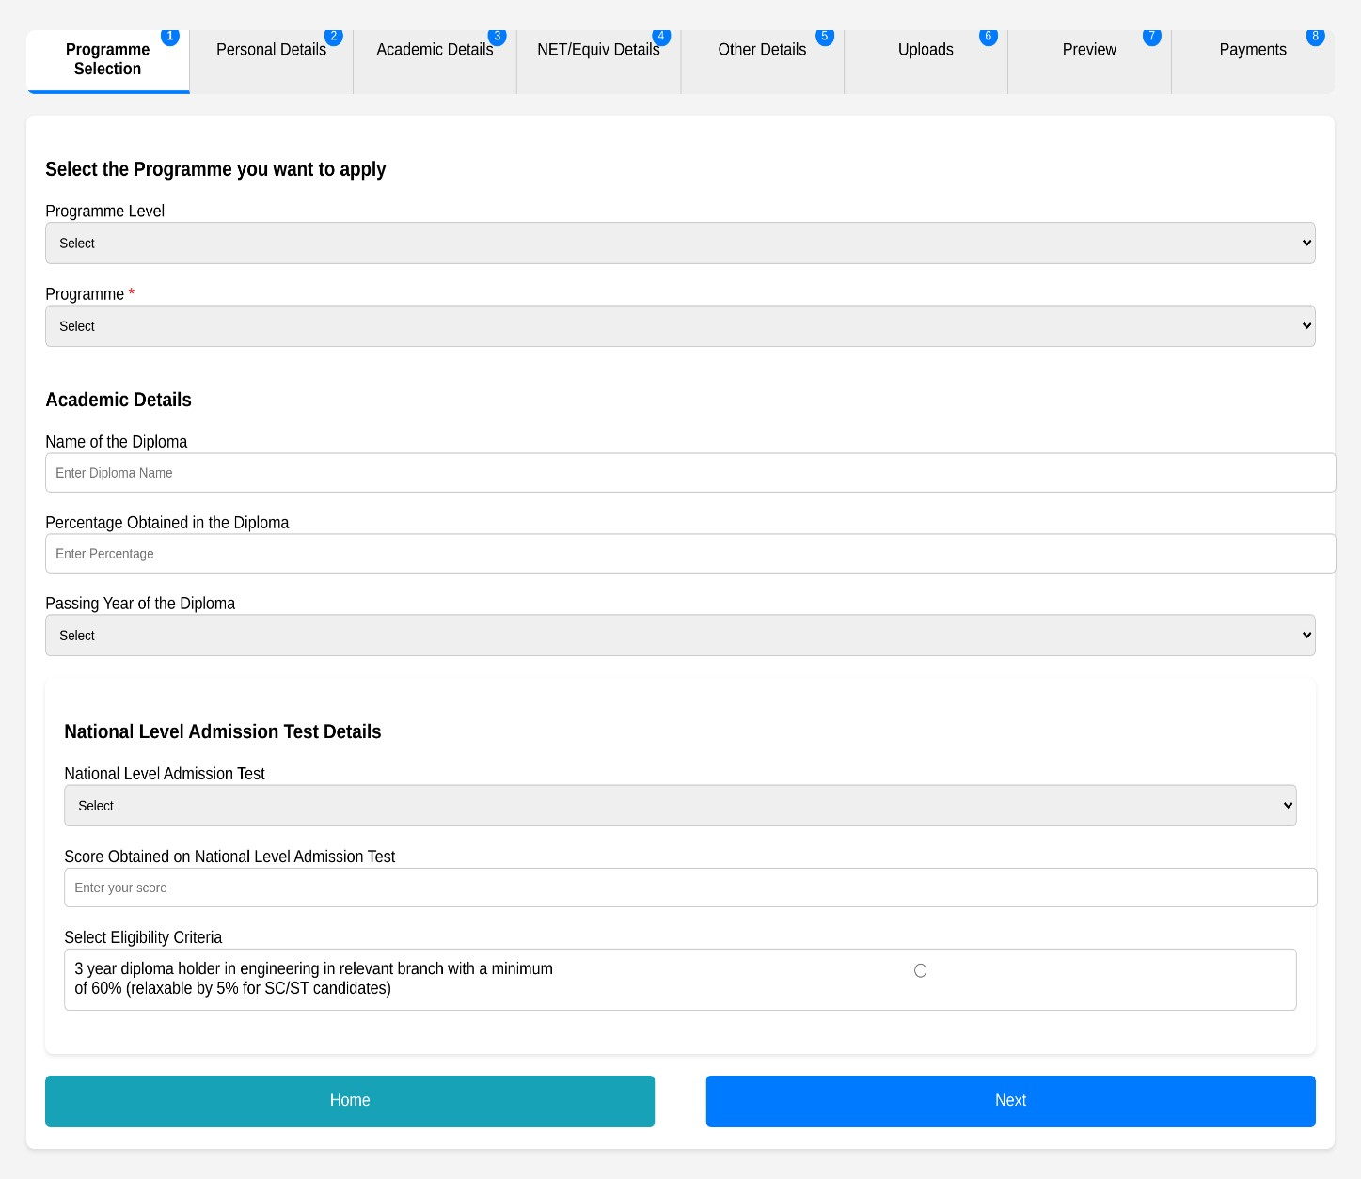

# 6th page code :-

<!DOCTYPE html>

<html lang="en">

<head>

<meta charset="UTF-8">

<meta name="viewport" content="width=device-width, initial-scale=1.0">

<title>Mizoram University Admission 2022</title>

<style> body { font-family: Arial, sans-serif; background-color: #f4f4f4; margin: 0; padding: 0;

}

.header {

background-color: #00A6B3; color: white; padding: 20px; text-align: center; position: relative;

}

.header img { border-radius: 50%; width: 50px; position: absolute; top: 10px; right: 10px;

}

.header a {

color: white;

margin: 0 15px;

text-decoration: none;

}

.main-container { margin: 20px; background-color: white; padding: 20px; border-radius: 10px;

}

.main-container h2 { text-align: center; color: #00A6B3;

}

.tabs { display: flex; justify-content: space-between; border-bottom: 2px solid #ccc; margin-bottom: 20px;

}

.tabs a {

padding: 10px; color: #00A6B3; text-decoration: none; font-weight: bold;

}

.tabs a.active { border-bottom: 3px solid #00A6B3;

}

.form-section label { display: block;

margin-top: 15px; font-size: 16px;

}

.form-section input, .form-section select { width: 100%; padding: 10px; margin-top: 5px; border-radius: 5px; border: 1px solid #ccc; font-size: 14px;

}

.form-section p { font-size: 12px; color: #555;

}

footer { text-align: center; margin-top: 20px; font-size: 12px; color: #555;

}

</style>

</head>

<body>

<div class="header">

<h1>Mizoram University Admission 2022</h1>

<a href="#">Download Admission Notice</a>

<a href="#">Download Prospectus</a>

<a href="#">Visit Mizoram University Website</a>

<div style="display: inline-block; float: right;">

<span>Name</span>

<img src="path_to_image.jpg" alt="User Image">

</div>

</div>

<div class="main-container">

<h2>Master of Business Administration (Management)</h2>

<div class="tabs">

<a href="#">Programme Selection <span>1</span></a>

<a href="#">Personal Details <span>2</span></a>

<a href="#" class="active">Academic Details <span>3</span></a>

<a href="#">Other Details <span>4</span></a>

<a href="#">Uploads <span>5</span></a>

<a href="#">Preview <span>6</span></a>

<a href="#">Payments <span>7</span></a>

</div>

<!-- Form Section -->

<div class="form-section">

<label for="x-year">Class X Year of Passing *</label>

<select id="x-year" name="x-year">

<option value="" disabled selected>Select</option>

<option value="2024">2024</option>

<option value="2023">2023</option>

<option value="2022">2022</option>

<!-- Add more options as required -->

</select>

<label for="x-percentage">Class X Percentage (If your mark is in CGPA, please convert it to equivalent percentage as per your CGPA score and CGPA scale) *</label>

<input type="text" id="x-percentage" name="x-percentage" placeholder="Enter your percentage">

<label for="x-institution">Class X Name of the Institution *</label>

<input type="text" id="x-institution" name="x-institution" placeholder="Enter institution name">

<label for="x-board">Class X Board/University *</label>

<input type="text" id="x-board" name="x-board" placeholder="Enter board or university">

<label for="x-subjects">Class X Subject Combination *</label>

<input type="text" id="x-subjects" name="x-subjects" placeholder="Enter subjects">

<label for="x-institution">Class X Name of the Institution *</label>

<input type="text" id="x-institution" name="x-institution" placeholder="Enter institution name">

<label for="x-board">Class X Board/University *</label>

<input type="text" id="x-board" name="x-board" placeholder="Enter board or university">

<label for="x-subjects">Class X Subject Combination *</label>

<input type="text" id="x-subjects" name="x-subjects" placeholder="Enter subject combination">

<label for="x-division">Class X Division *</label>

<select id="x-division" name="x-division">

<option value="" disabled selected>Select</option>

<option value="first">First Division</option>

<option value="second">Second Division</option>

<option value="third">Third Division</option>

</select>

<p>© Mizoram University 2022 | Powered by: PROJECT SAMARTH</p>

</div> </div>

<footer>

<p>© Mizoram University 2022 | Powered by: PROJECT SAMARTH</p> </footer>

</body>

</html>

## 6th page output :-

